Task on IAM:

===========

1. Create one IAM user and assign ec2,s3 full access role.

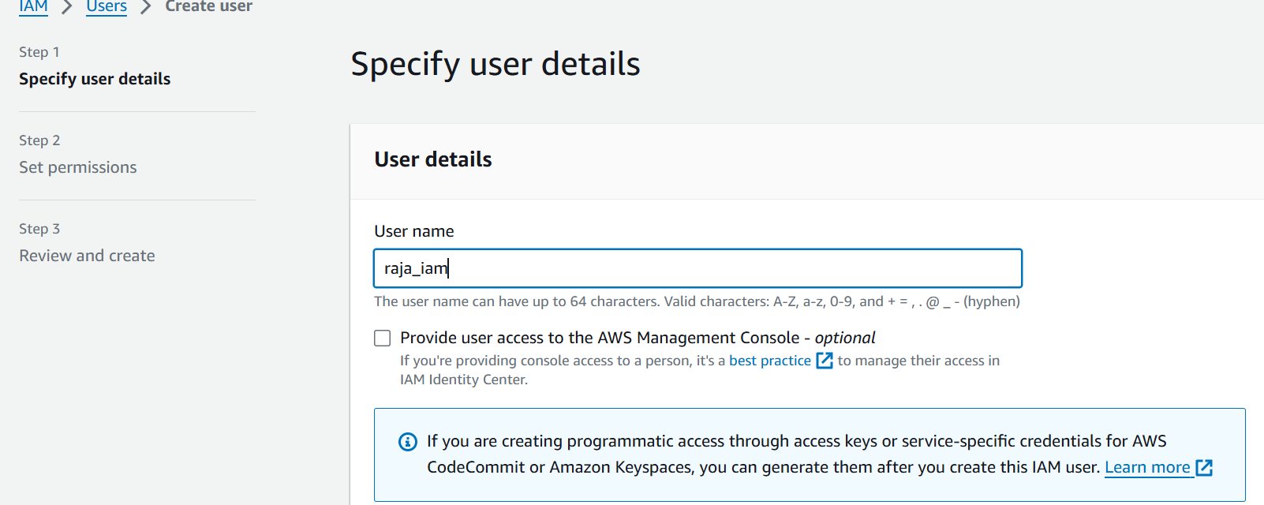

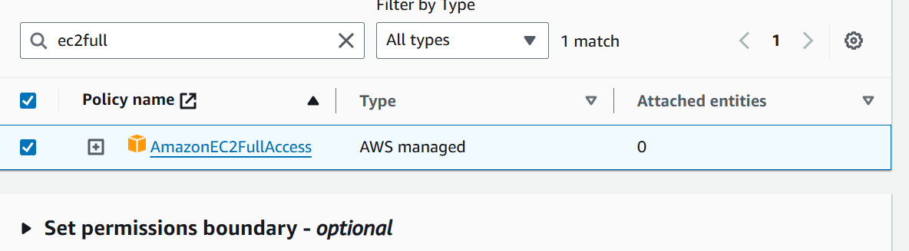

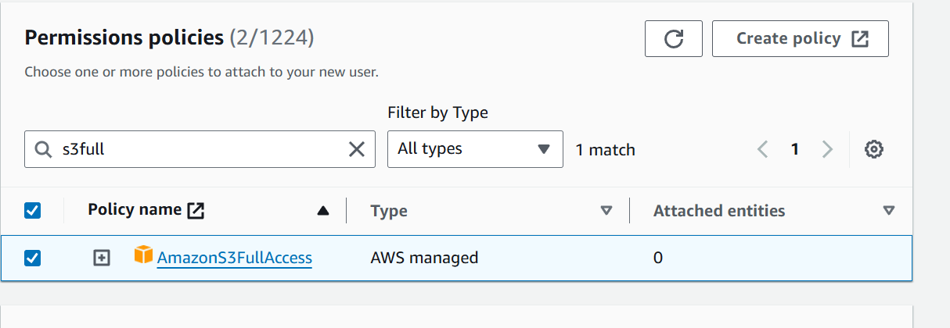

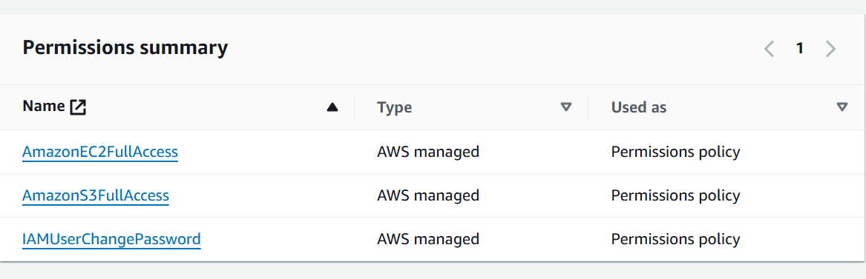

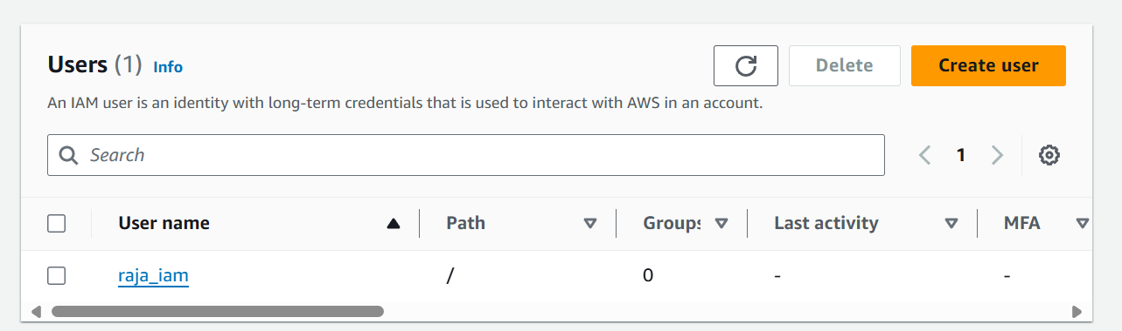

1. Create one Group in IAM and Assign Read access for ec2.

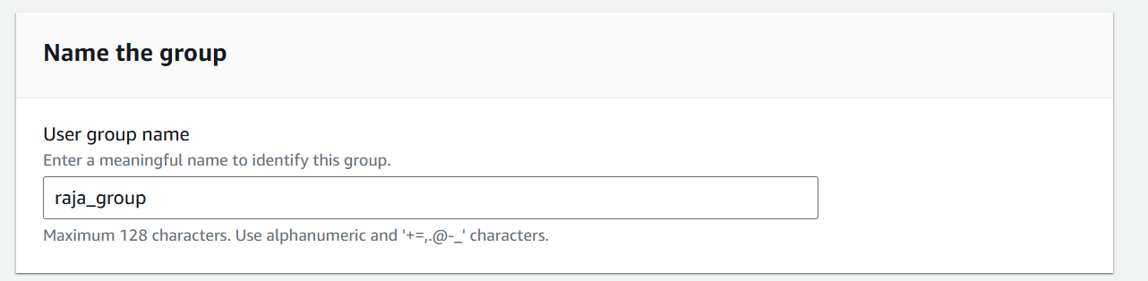

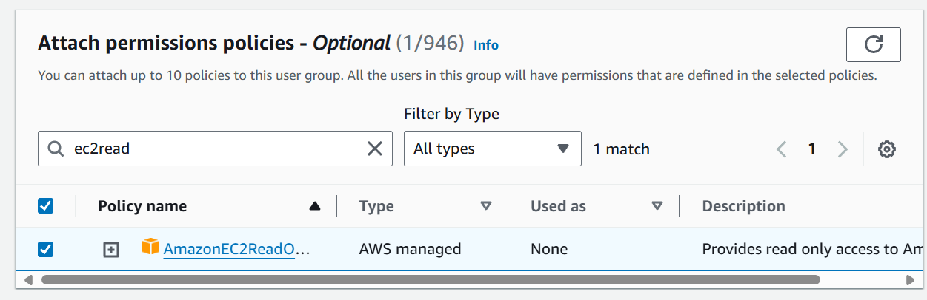

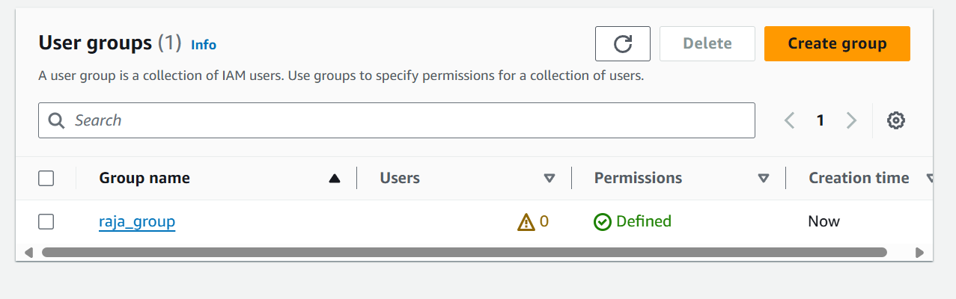

1. Create a new user with name Devops and add to the group created in task2.

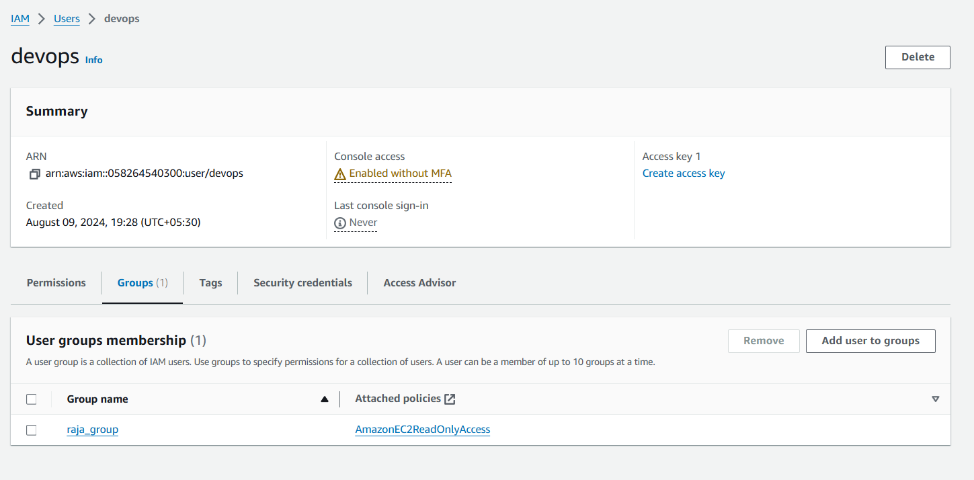

1. Write a bash script to create a IAM user with VPC full access.

#!/bin/bash# Define variables  
IAM_USER_NAME="Hello_World"  
POLICY_NAME="AmazonVPCFullAccess"  
POLICY_ARN="arn:aws:iam::aws:policy/AmazonVPCFullAccess"# Create the IAM user  
aws iam create-user --user-name $IAM_USER_NAME# Attach the VPC full access policy to the user  
aws iam attach-user-policy --user-name $IAM_USER_NAME --policy-arn $POLICY_ARN# Optionally create access keys for the user  
ACCESS_KEYS=$(aws iam create-access-key --user-name $IAM_USER_NAME)# Print the access keys  
echo "Access keys for user $IAM_USER_NAME:"  
echo $ACCESS_KEYSecho "IAM user $IAM_USER_NAME created and granted VPC full access."

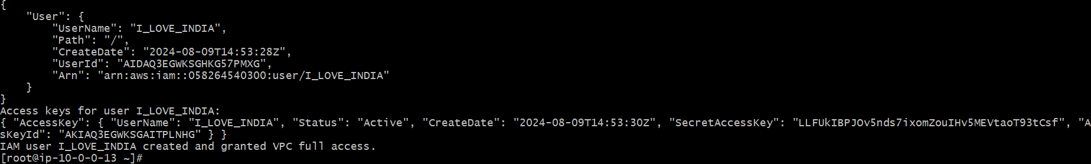

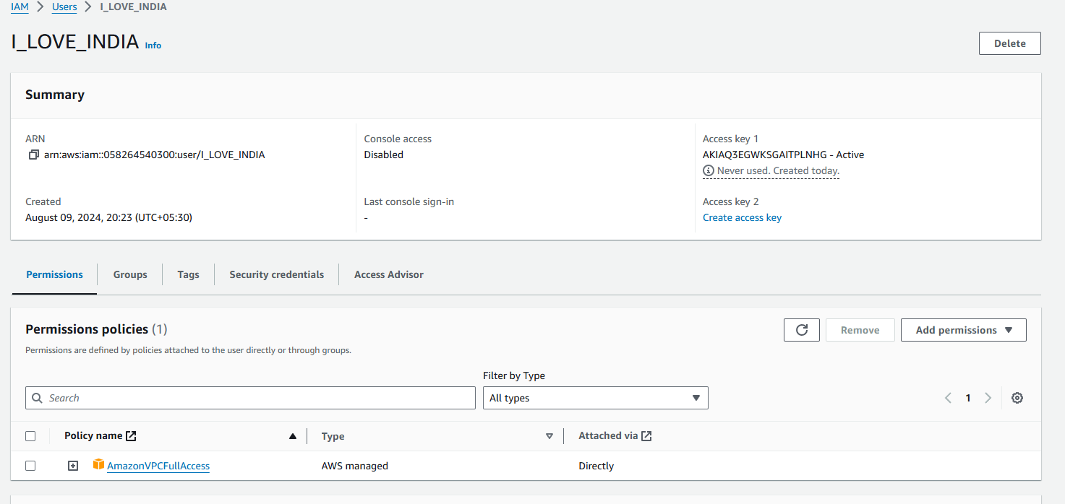

1. Create a IAM policy to access ec2 for a specific user in specific regions only.

{  
    "Version": "2012-10-17",  
    "Statement": [  
        {  
            "Action": "ec2:*",  
            "Resource": "*",  
            "Effect": "Allow",  
            "Condition": {  
                "StringEquals": {  
                    "ec2:Region": "us-east-2"  
                }  
            }  
        }  
    ]  
}

